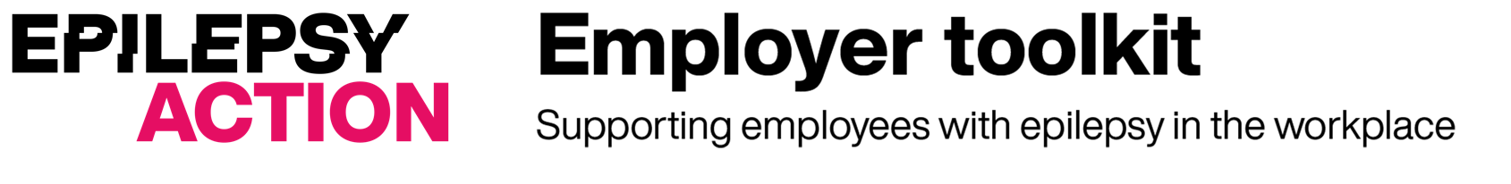

Epilepsy risk assessment template

Employee name
Job title

Assessment carried out by
Date of assessment

Date of next review

What are the hazards?  (add the hazards from your general risk assessment) | Who might be harmed and how? | What are you already doing to control the risks? | What further action do you need to take to control the risks? | Who needs to carry out the action? | When is the action needed by? | Done
Display screen equipment (DSE)
Falls, slips and trips
Work environment

What are the hazards?  (add the hazards from your general risk assessment) | Who might be harmed and how? | What are you already doing to control the risks? | What further action do you need to take to control the risks? | Who needs to carry out the action? | When is the action needed by? | Done
Hot water /scalds
Stress and fatigue
Manual handling |  | .
Working at height
Machinery
Lone working
Chemicals/ substances hazardous to health

What are the hazards?  (add the hazards from your general risk assessment) | Who might be harmed and how? | What are you already doing to control the risks? | What further action do you need to take to control the risks? | Who needs to carry out the action? | When is the action needed by? | Done
Electrical equipment
Evacuation during fire and other emergencies
First aid

Template based on the Health and Safety Executive’s risk assessment template

This template is part of the Epilepsy Action Employer toolkit. See employers.epilepsy.org.uk for more resources to help support people with epilepsy at work.

Epilepsy Action is the working name of British Epilepsy Association, a registered charity in England and Wales (No. 234343) and a company limited by guarantee (No. 797997) in England.

© Copyright Epilepsy Action 2024 Published November 2024 To be reviewed November 2027

