Step Together Toolkit- Guidance for Completion

Who should complete the Toolkit
The Step Together benchmarking toolkit looks at all aspects of care for people with epilepsy and learning disabilities. To get the most from the toolkit you will need input from colleagues across your service. This can include commissioners, consultants in neurology and psychiatry, nurses in epilepsy and learning disabilities, social care staff, admin staff, primary care staff and any other colleagues who may be involved in the care of this population.
We recommend that the lead person reads through the questions and decides who needs to input into each question. You can then send those questions on to the relevant people for feedback. The lead person should then collate the responses, and where there is disagreement, enter an answer that is an average of the responses you’ve received.

Practical advice
- Please save the toolkit with your ICS/Trust name in the file name.
- Ensure you save regularly.
- You should begin completing the toolkit from the ‘Introduction’ page. You can navigate to specific pages by clicking the labels at the top:
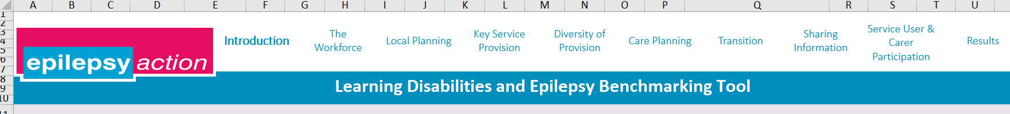
And you can move to the next page using the arrows at the bottom:

Do not use the excel sheet tabs at the bottom, as changes to some of those tabs would prevent the toolkit from working correctly.
- Please answer the questions using the drop-down boxes. The only exceptions to this are questions 14, 24 and 25 which ask you to enter a number.
- Only respond ‘not sure’ if you’re unable to find an answer from a relevant colleague in that area. If you’re unable to find an answer for a question that does not have a ‘not sure’ option, leave the question blank
- Some questions prompt further questions, as in the example below. Please only answer the relevant boxes (i.e. if you have answered yes, only answer the following ‘if yes’ question, and do not answer the ‘if no’ question)
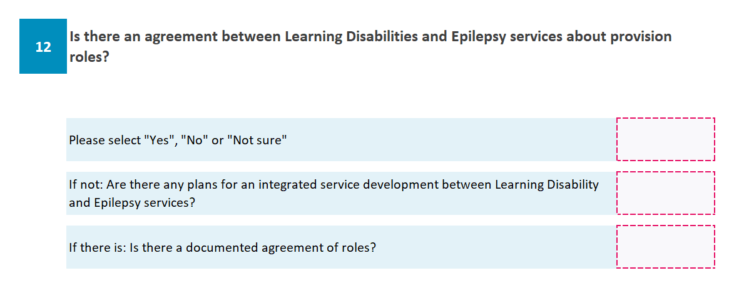
- Some questions are based on opinions, such as the question below. Please gather the opinions of multiple relevant colleagues and answer based on their average response.

Definitions
- Primary care is GP services, secondary care is hospital-based services (for the purposes of this toolkit, this also includes tertiary care).

Returning results
Please ignore the ‘Send Results’ page. You can send your results by saving the toolkit and emailing it to researchadmin@epilepsy.org.uk

Guidance on specific questions
Introduction:
- This page should be completed by the person leading on the toolkit completion. If you are completing it on behalf of an ICS, the ‘Trust’ question should be left blank.
Key Service Provision:
- 19B This question uses ‘annual health checks’ to mean ‘annual health checks of epilepsy’.
Transition:
- This section uses ‘transition’ to mean transition from children’s to adults’ services
Sharing information:
- 46 This question is not a grid; please pay attention to the services named above each box when responding
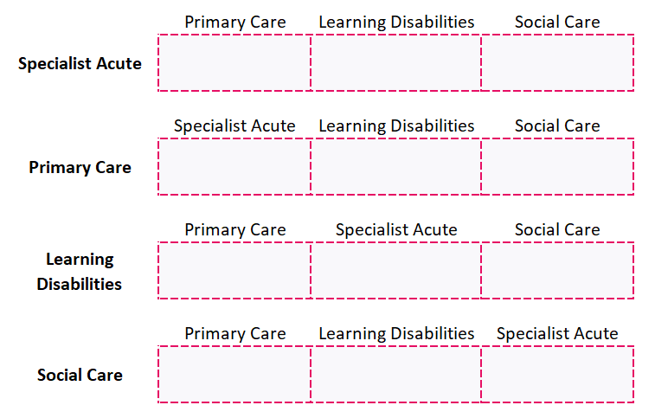
User and Carer Participation:
- 54 This question needs input from carers. If you don’t have a way to get this input, please use the opinions of relevant colleagues, but do not answer ‘strongly agree’.

Results
At the top of the results page is your overall score. This is the average result across all pages. It will be categorised as either red, amber or green depending on how well it aligns with the Step Together guidelines’ recommendations for an ideal service.
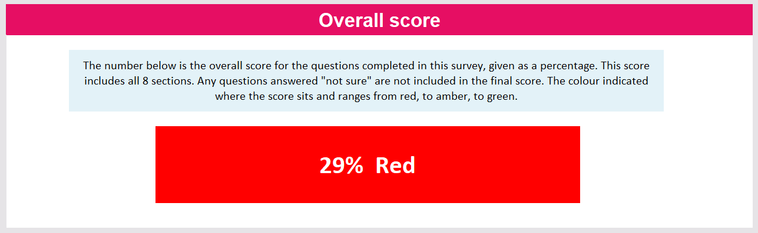

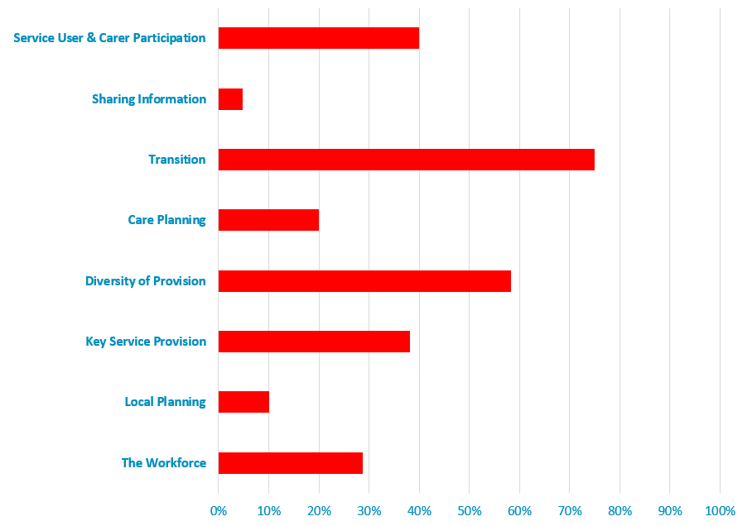
Beneath this is a breakdown of each section, shown on a graph. This shows you which areas align well with the Step Together guidance, and which areas do not. The graph updates automatically as answers are input, so it will only be a true reflection of the service when all questions have been answered.

